**Lesson Seventeen: The Raising of Lazarus**

**Perea to Bethany. The Raising of Lazarus (John 11:1-46)**

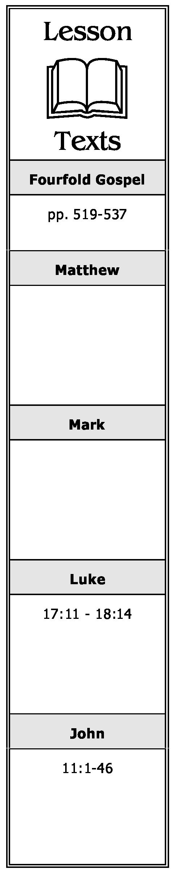

1. What occasioned the miracle performed in this chapter?
2. What was Jesus’ initial reaction to the news about Lazarus? What did His disciples think He meant by it?
3. Why did Jesus’ disciples try to discourage Him from going to Bethany where Lazarus was? Why did He said He must go to Lazarus?
4. What manifestations of faith in Jesus are seen in this incident? Describe each.
5. Why do you think Jesus wept as He stood before the tomb of Lazarus?
6. What was the reaction of the Jews to the miracle Jesus performed?
7. What were some of the consequences of this miracle?

**Retiring Before the Sanhedrin’s Decree (John 11:47-54)**

1. Where did Jesus go after leaving Bethany? Why did He go there?
2. What question did the Jews ask in reference to Jesus at the Passover? What order had the chief priests and Pharisees given at the feast in relation to Jesus?

**Journey to Jerusalem. Ten Lepers. Concerning the Kingdom (Luke 17:11-37)**

1. What request did ten lepers make of Jesus as He entered a village? What was His reply to them? What was the result?
2. What was the reaction of these lepers when they discovered they were healed?

**A Chronological Study of the Life of Jesus Gene Taylor 46**

1. What did Jesus say to the one leper who returned to Him?
2. What was Jesus’ reply to the Pharisees who asked Him when the kingdom of God should come?
3. In warning His disciples not to be deceived by the false “christs” who would appear, how did Jesus make it clear that His coming would be obvious to all?
4. What did Jesus say had to first come to pass before He would come in His glory?
5. To what two previous events did Jesus liken the conditions which would exist at His coming?

**The Parable of the Importunate Widow (Luke 18:1-8)**

1. Briefly summarize this parable.
2. What lesson was it intended to teach?

**The Parable of the Pharisee and Publican (Luke 18:9-14)**

1. Briefly summarize this parable.
2. What lesson was it intended to teach?

**A Chronological Study of the Life of Jesus Gene Taylor 47**